Tanmay Fadnavis

SUID: 971141760

Computer Security

Lab-4

# TASK 1: EXPLOIT THE RACE CONDITION VULNERABILITY

The screen shots for task-1 are below.

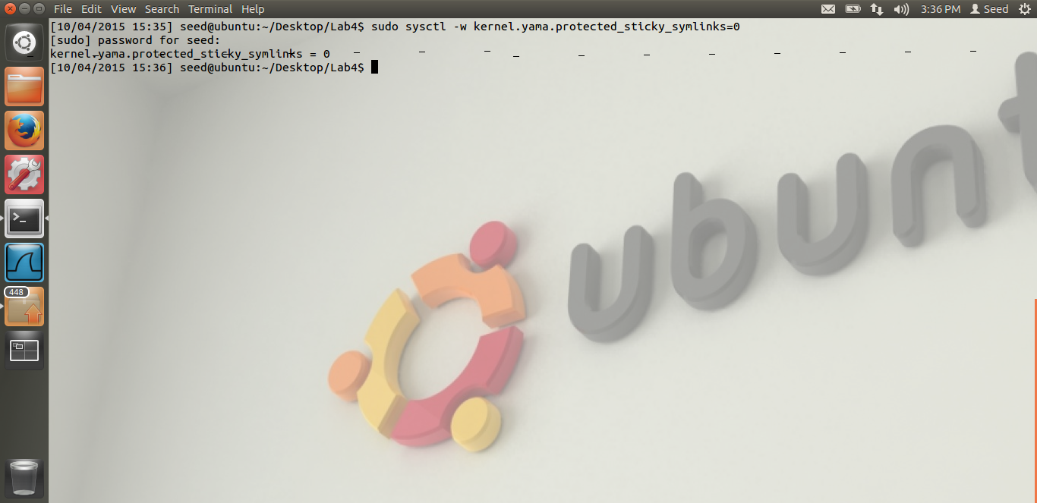

Here in the above screen shot, we are disabling the ubuntu’s symlink protection.

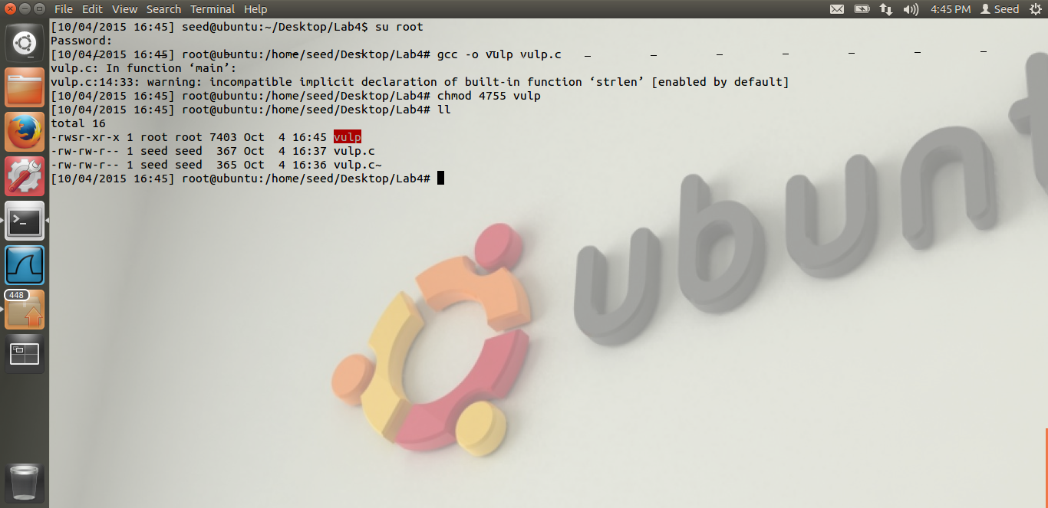

I have compiled the vulnerable program given by Dr. Du. As seen from the screen shot, I have made it a set-UID program. The red color shows the same.

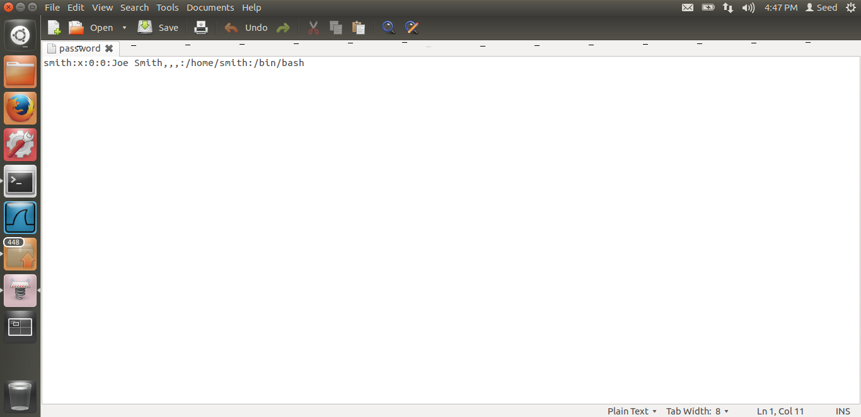

In this task1, we need to over-write 2 files, owned by the root, the /etc/passwd file and the etc/shadow file. Thus, the first attack is to overwrite the password file. The password file format is given in the lab. As seen from the screen shot, I am just changing the 3rd and 4th column to be 0. This is because, we need our smith user to have root priviledges. Making it 0 will make smith a root. This is what we want. We will be writing this in the /etc/passwd file.

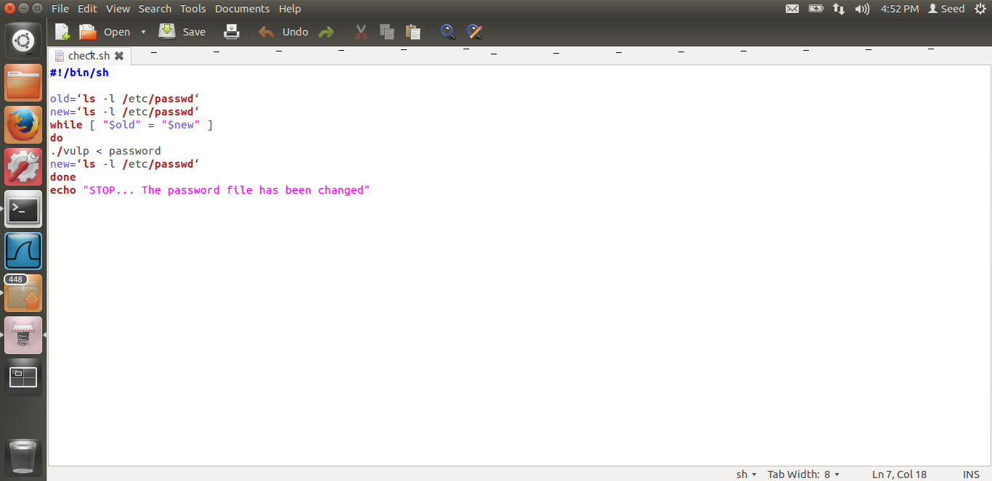

From the above screen shot, we can see the check.sh shell script. The loop to check has been given by Dr. Du. I am just executing the set-UID vulp program and taking the input from the password file.

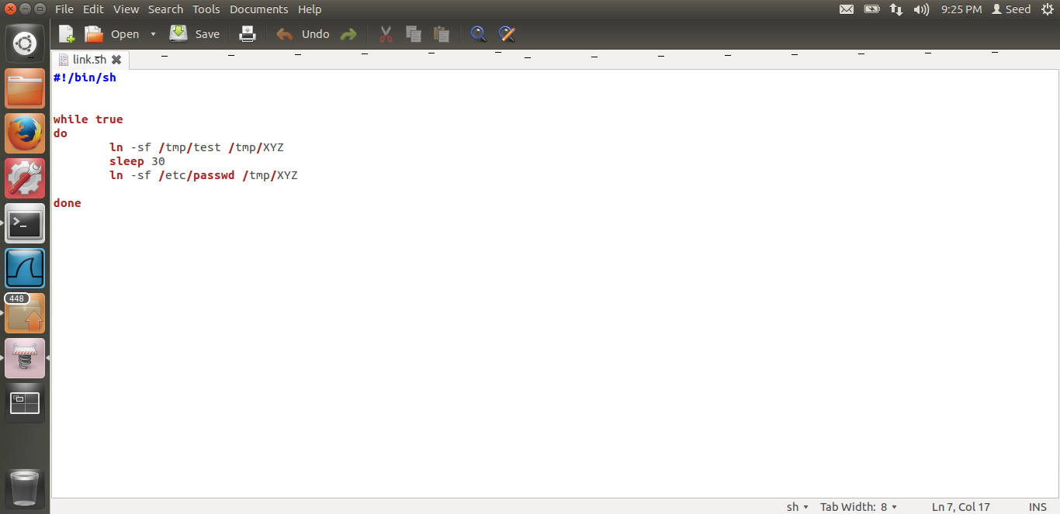

This is the link.sh shell script. First, we are linking our temp file /tmp/XYZ to our normal file /tmp/test which I have created. Secondly, we are then sleeping for 30 secs. Then I am linking the /tmp/XYZ file to the /etc/password file. The race condition, we will win, if there is a context switch after the check and before the use.

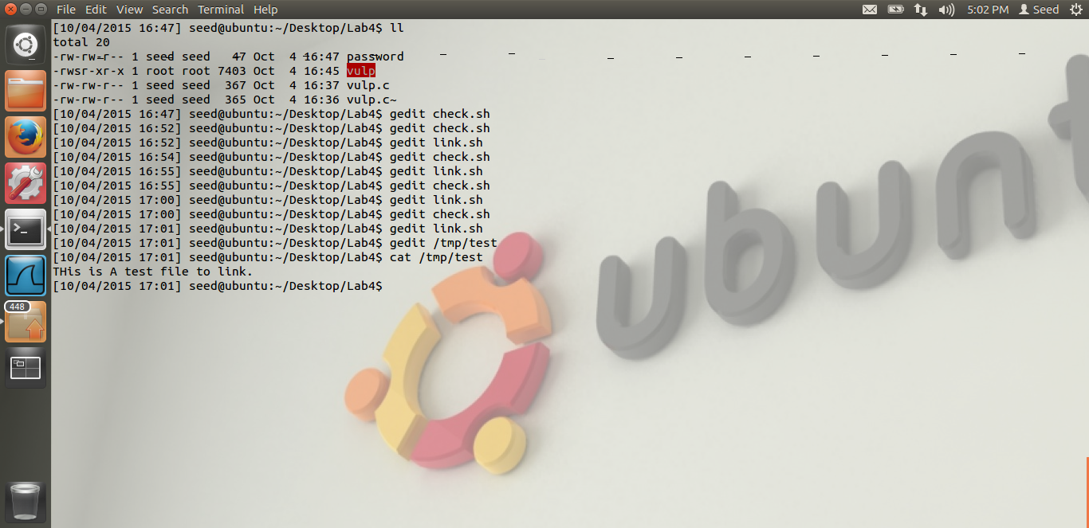

Here, I have just used cat, to show the /tmp/test file which I have created.

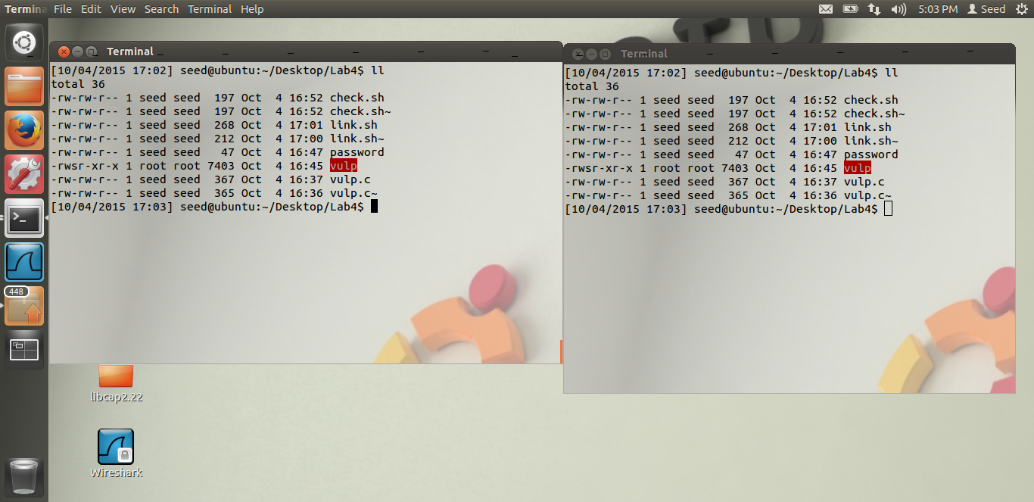

I have just opened 2 terminals. As we have to run the 2 shell scripts simultaneously. We will try the race condition attack now.

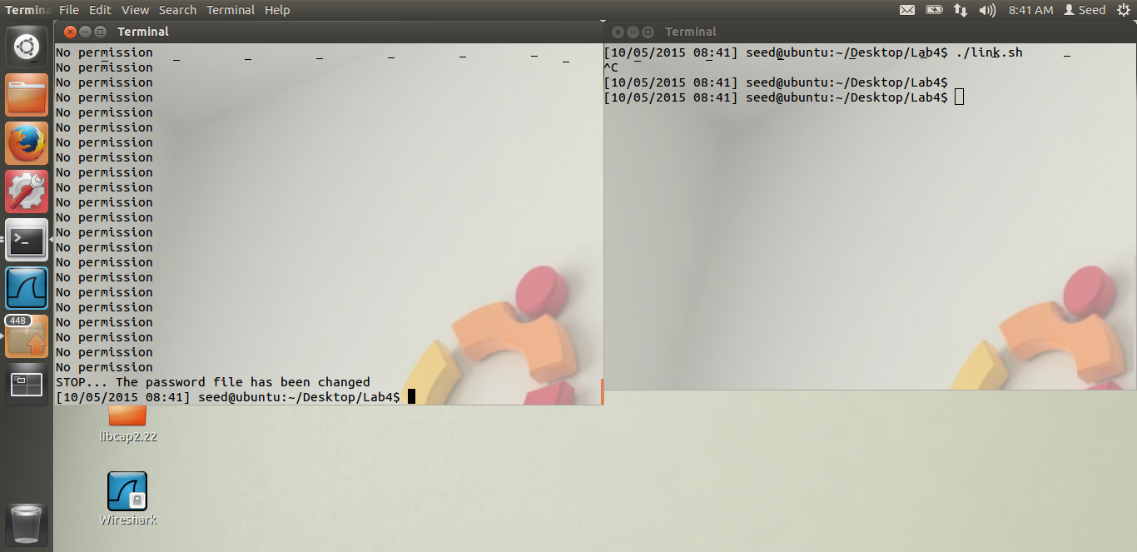

From the above screen shot, we can see that the attack was successful. After lot of no permissions, there was a context switch at the correct moment. We can see that the password file has been changed. And our check.sh has been stoped. Thus, the attack was successful.

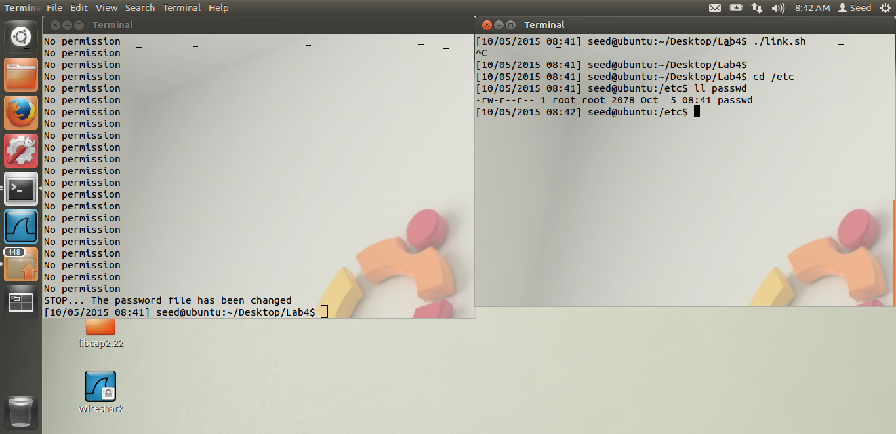

On the second terminal, we can see that the passwd file, the modified date is the date when I ran the attack. Now we will see whether our smith entry has been successfully added to the password file.

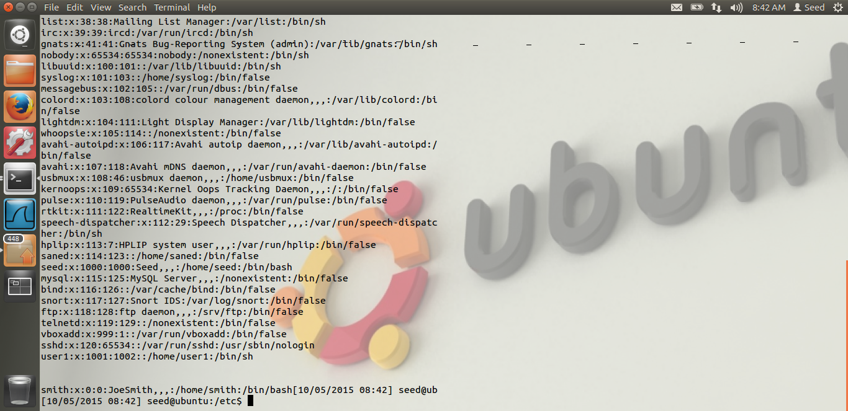

After doing a cat on the /etc/passwd file, we can see that the smith entry has been successfully added. Thus our attack is successful. Thus, we have won the race condition. As there was a context switch after the check and before the use, we linked our /tmp/XYZ file to the /etc/passwd file. Thus because of the time difference between TOC and TOU, we changed to the link, and hence our entry was added to the /etc/passwd file.

We will repeat the same for the /etc/shadow file.

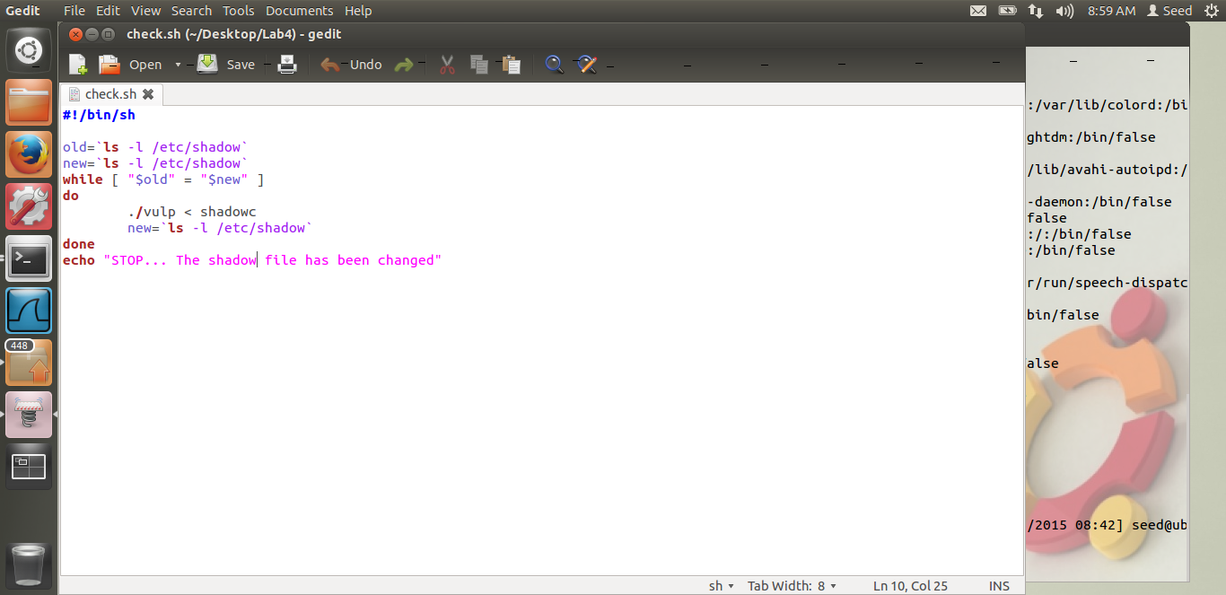

I have just changed my check.sh to execute on the /etc/shadow file now.

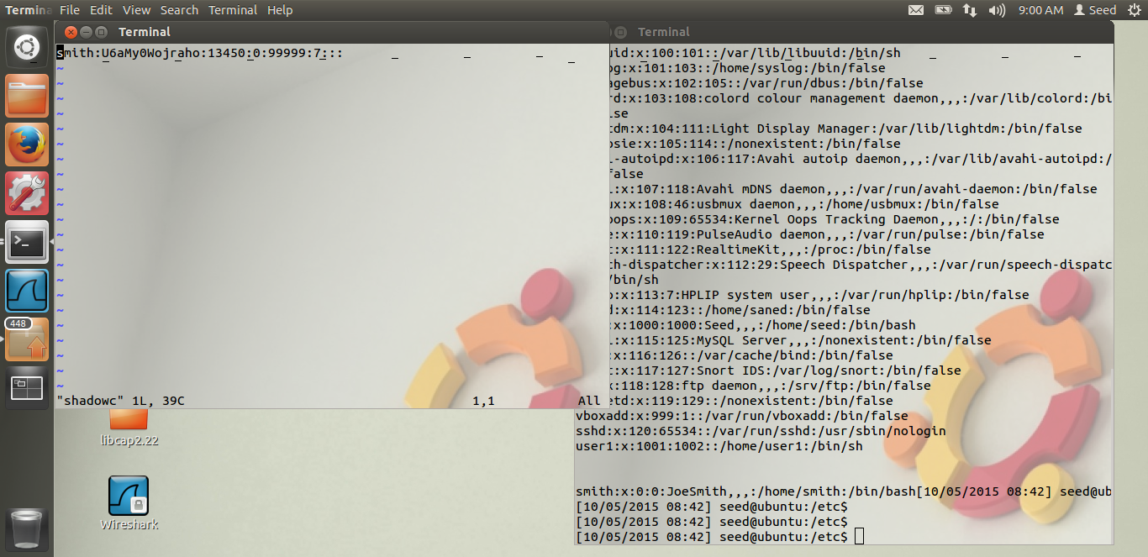

On the left terminal, we can see that I have added a entry to the shadow file. In the entry, we can see that the password is a blank password provided by the LA in his slides. We will write this in the /etc/shadow file.

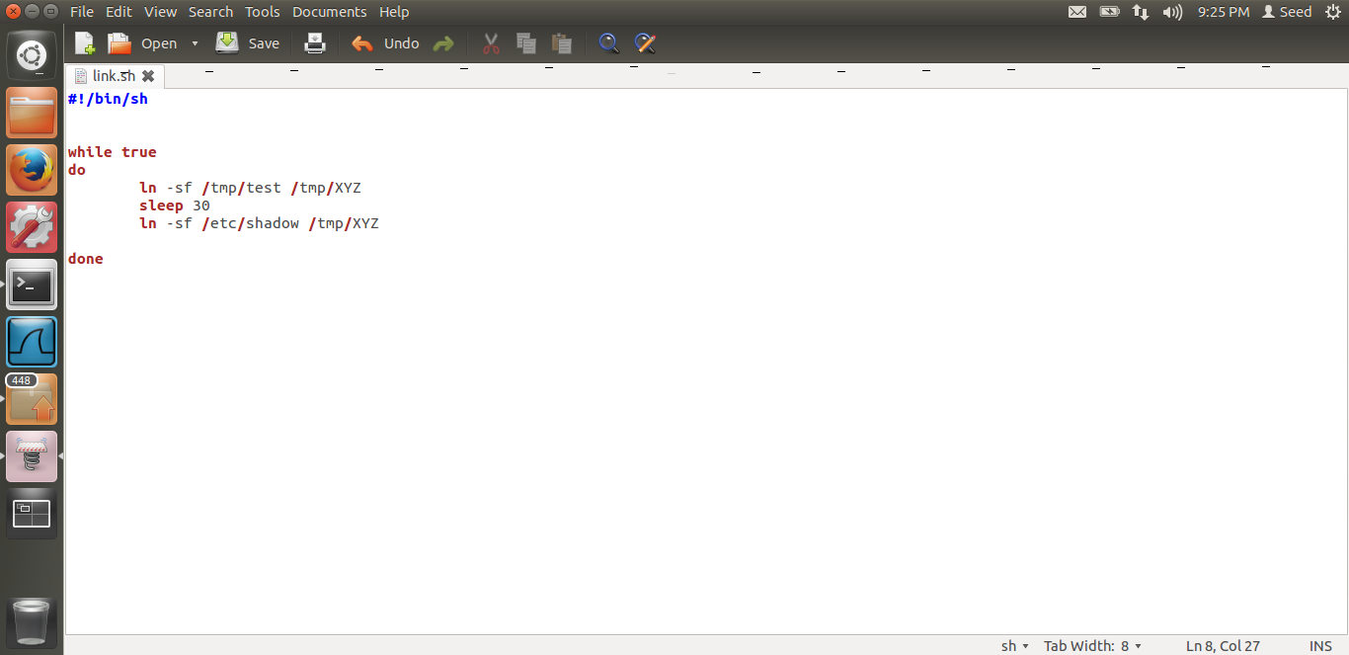

Just changed the link.sh for the shadow file.

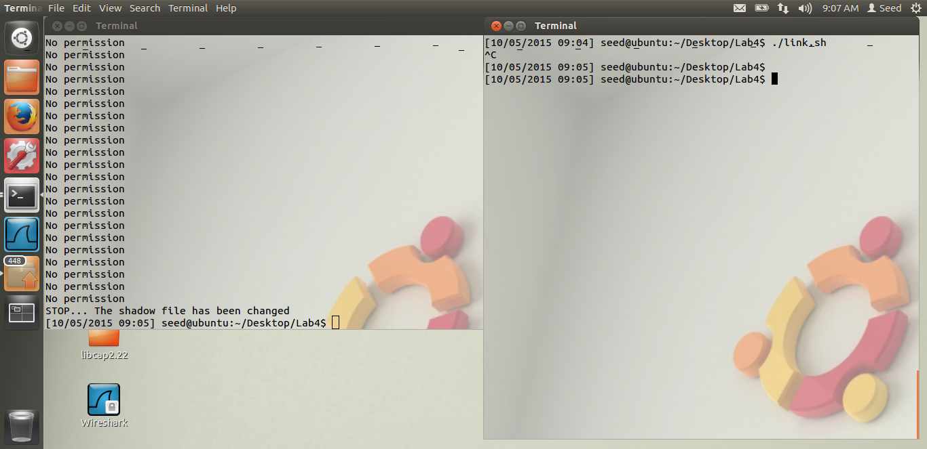

As you can see, when we run both the scripts, our shadow file has been changed. Hence the attack is successful.

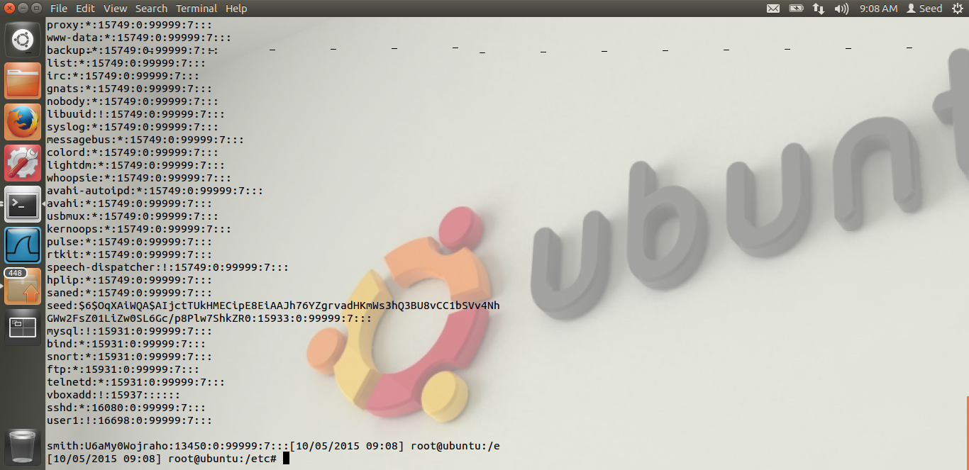

If we cat the shadow file, first I do su root, as the shadow file is readable to root only. Thus, we can see our entry is added to the shadow file. Thus our attack is successful due to race condition.

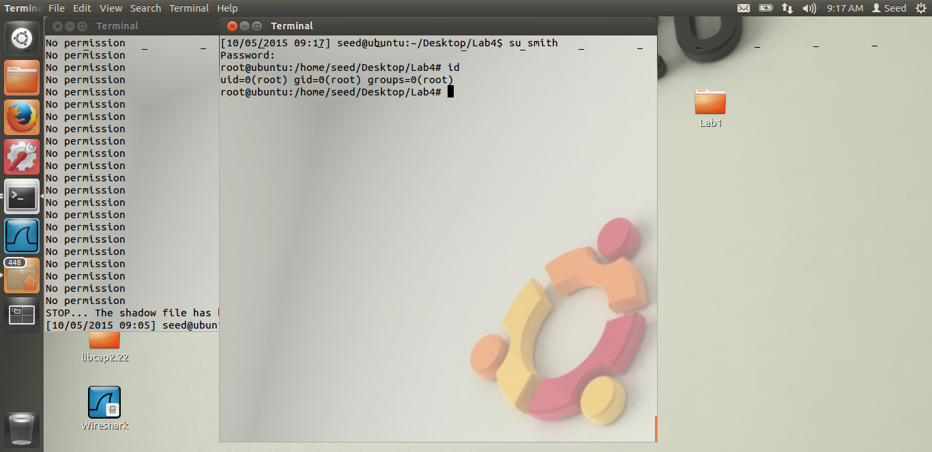

Now after our attack is successful, let us see if we have gained root priviledges. From the screen shot, we can see that, when we login as smith, su smith with a blank password, we get the root shell. Thus, we were successful in gaining the root privilege. If I run the id command, we can see that uid is 0. We have logged in as smith. Thus our attack was successful.

Thus we have completed Task 1.

# TASK 2: PROTECTION MECHANISM A- REPEATING

The screen shots for Task 2 are below.

In this task, I am adding the check condition loops, access check and checking the status of the i-nodes using lstat and fstat after every condition. Only if all the statuses are the same, only then I am writing in the file, else I am not.

The screen shot is below.

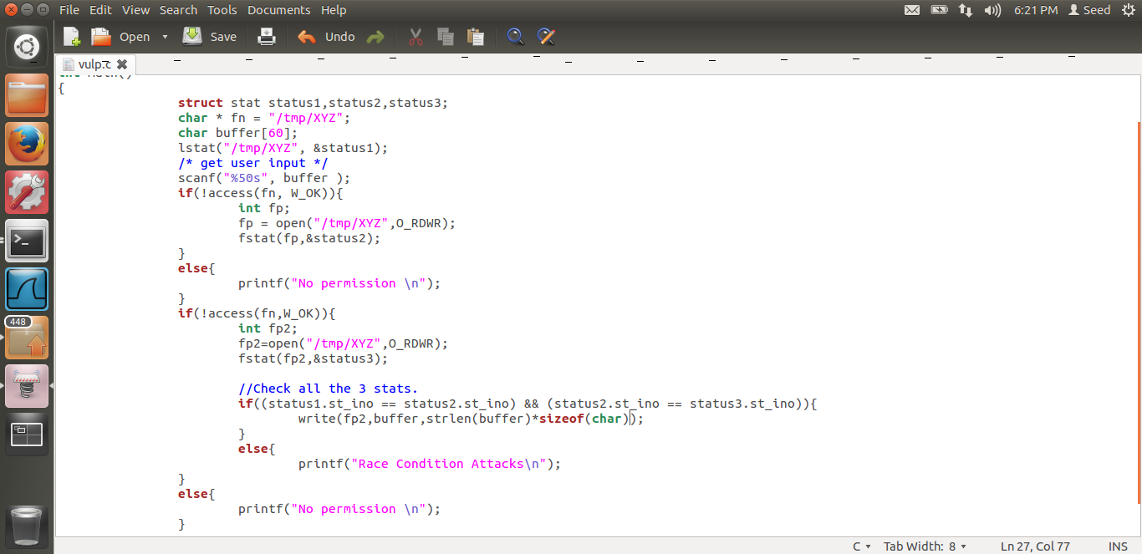

In the above program, I have added more if checks, before the file is open, I am using the lstat, to get the status of the link. After 1st access , I am opening the file and checking the staus using the fstat(). After 1 more access, I am opening the file and checking fstat. In this last access check, I am checking if all the 3 values are the same. Only If all the 3 values are the same, then I am writing it into the file, else I am printing that “Race Condition attacks”. Now let us run the program and see what happens.

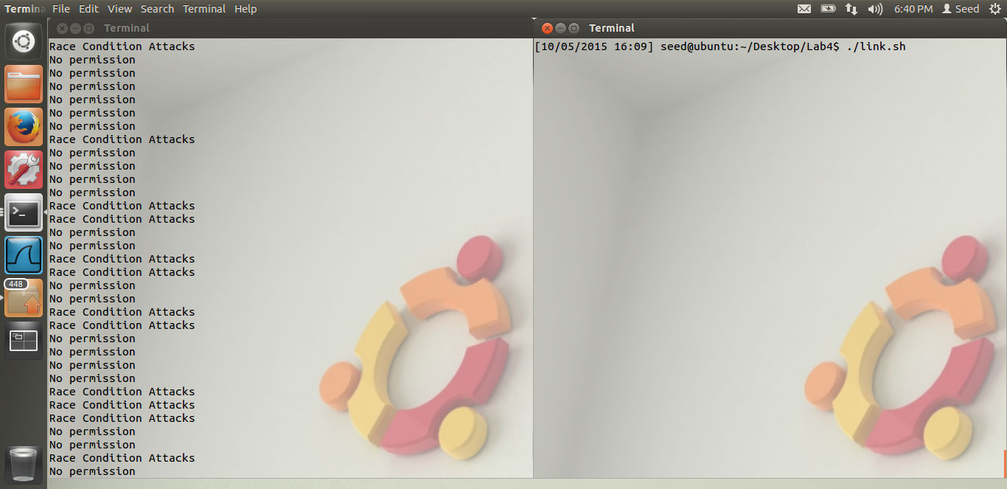

As you can see, the check.sh prints no permission and sometimes “race condition attacks”. Thus, I am not able to do the race condition attack successfully, even though keeping it for a long time.

As adding 3 checks, the time exponentially increases, thus, the only possibility of this happening is, after the condition is checked, the file is linked to /etc/passwd, then when the second access is checked, the link is changed again, and so on, and after the final check, the link is changed just before writing it to the file. Thus, as we have exponentially increased the time for the race condition to attack, I was not able to attack successfully.

# TASK 3: PROTECTION MECHANISM B-PRINCIPLE OF LEAST PRIVILEGE

The screen shots for task-3 are below.

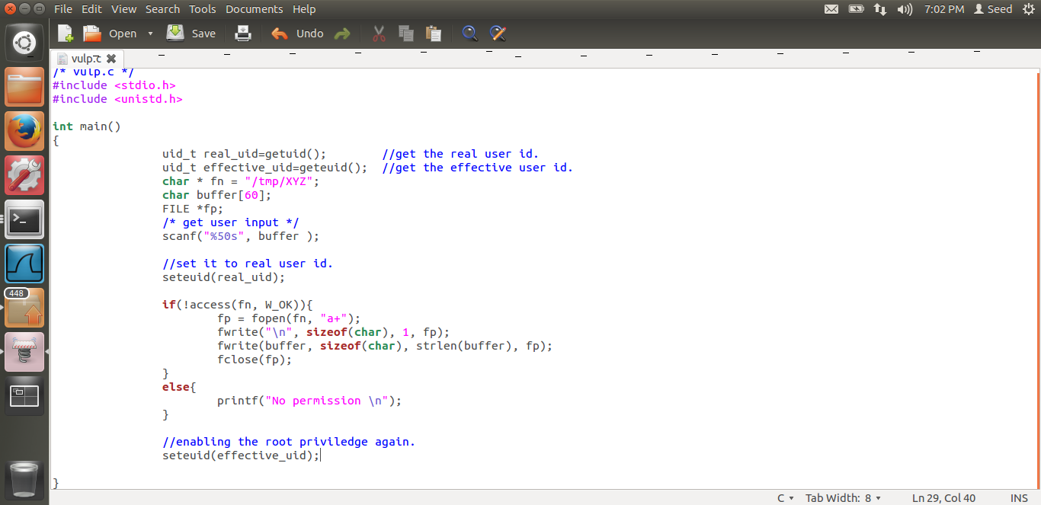

Thus, we have to the principle of least privilege, i.e. if we don’t need a high privilege to perform the operation, we reduce the privilege. Thus, in the vulnerable code, as you can see, I have reduced the privilege before checking the access. Using the seteuid(read_uid), Thus now, the effective uid is the real_uid, and not the root’s uid. Thus, when we do the open, the effective uid will be that of user’s and not the root’s. Hence this principle works in the race condition attacks. Reason is, even if the link is to the /etc/passwd file, as the effective uid is seed, in our case, we won’t b able to write to the /etc/passwd or the shadow file. I have again changed the effective uid to effective uid, after the operation is completed. Let us see whether the attack was successful.

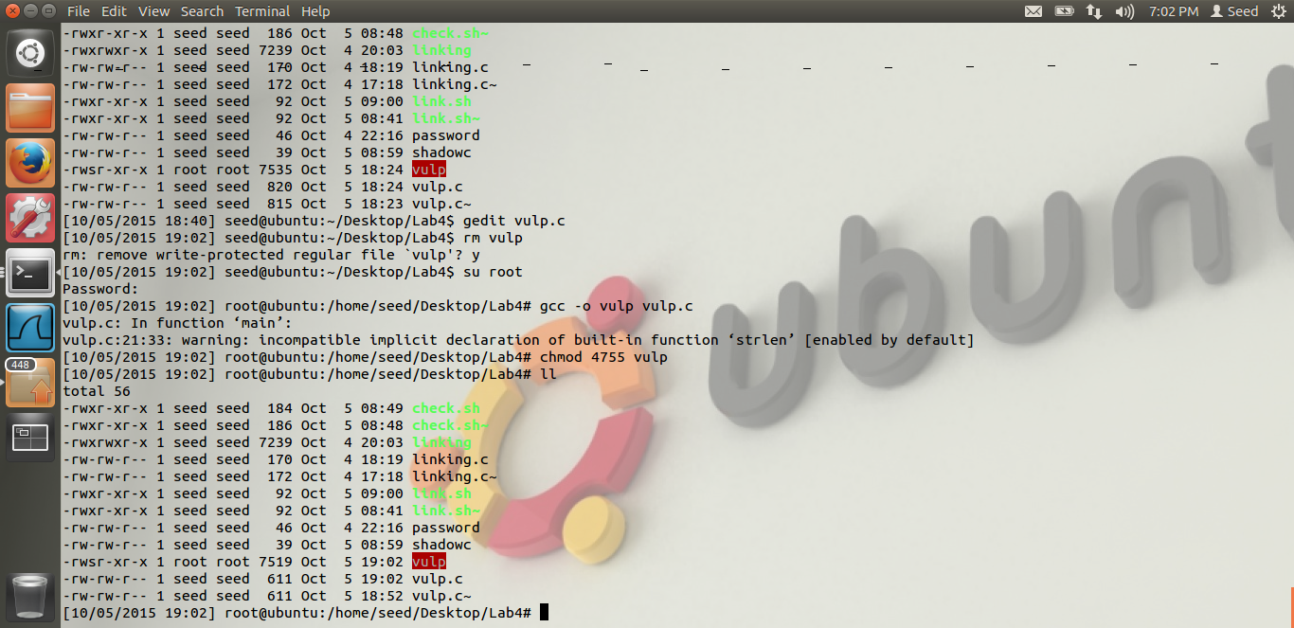

After making the changes, I have again made it a set-UID program.

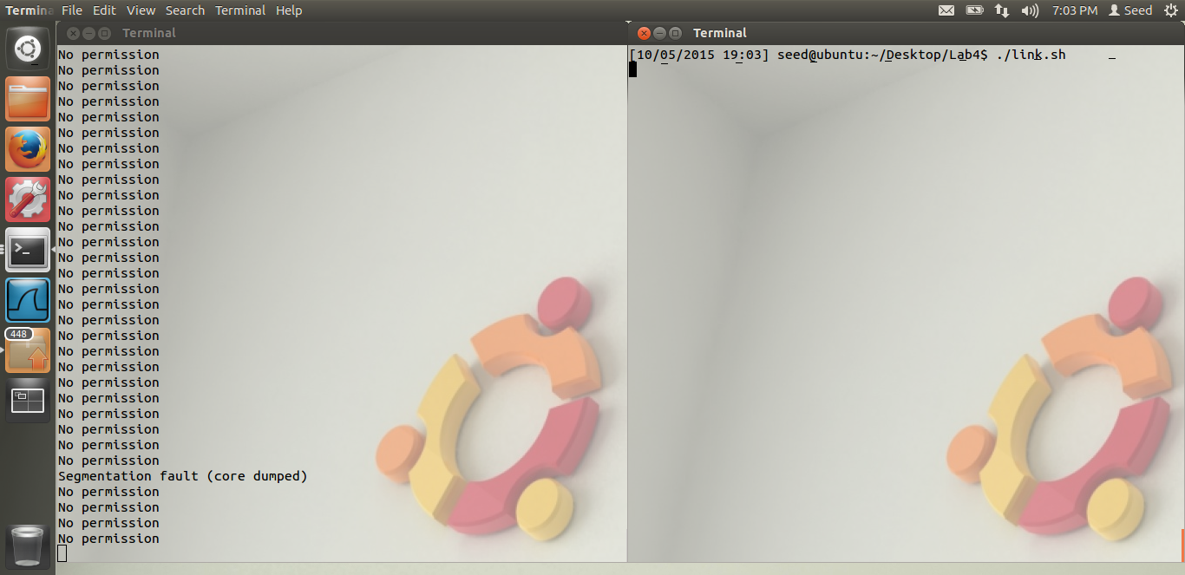

Thus, as you can see, we are getting the no permission outputs, i.e., we are not able to do the attack successfully because of the reason I explained above. Thus, the race condition attack does not work when we use the above approach.

# TASK 4: PROECTION MECHANISM C- UBUNTU’S BUILT IN SCHEME

The screen shots for Task-4 are below.

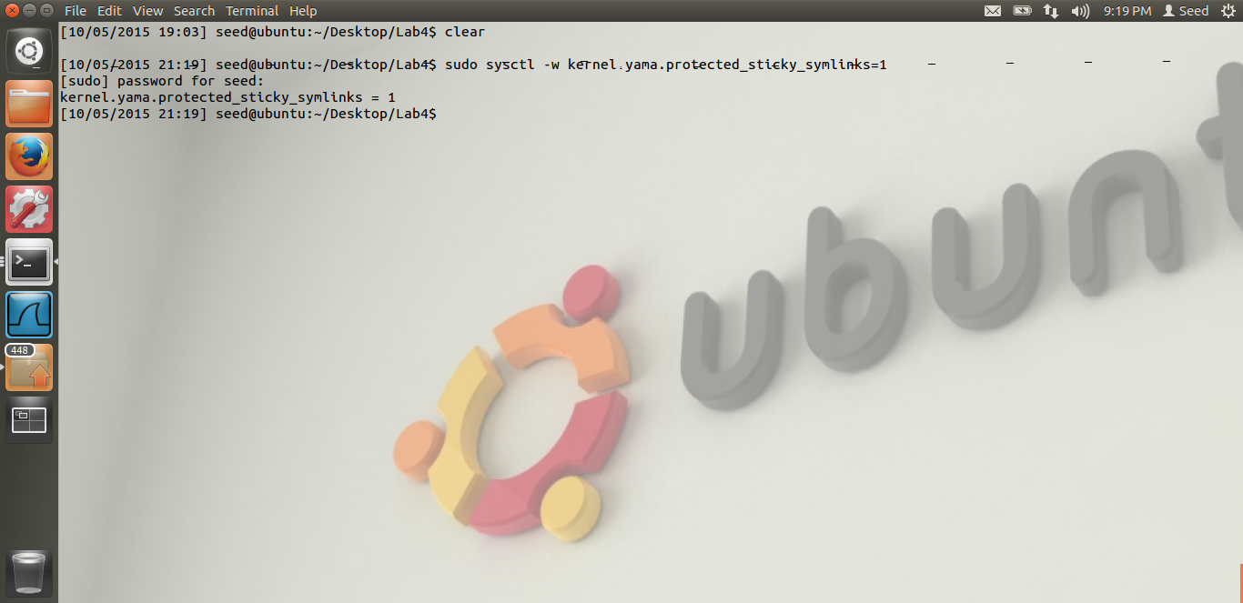

Initial set-up. I have re-activated ubuntu’s built in protection scheme.

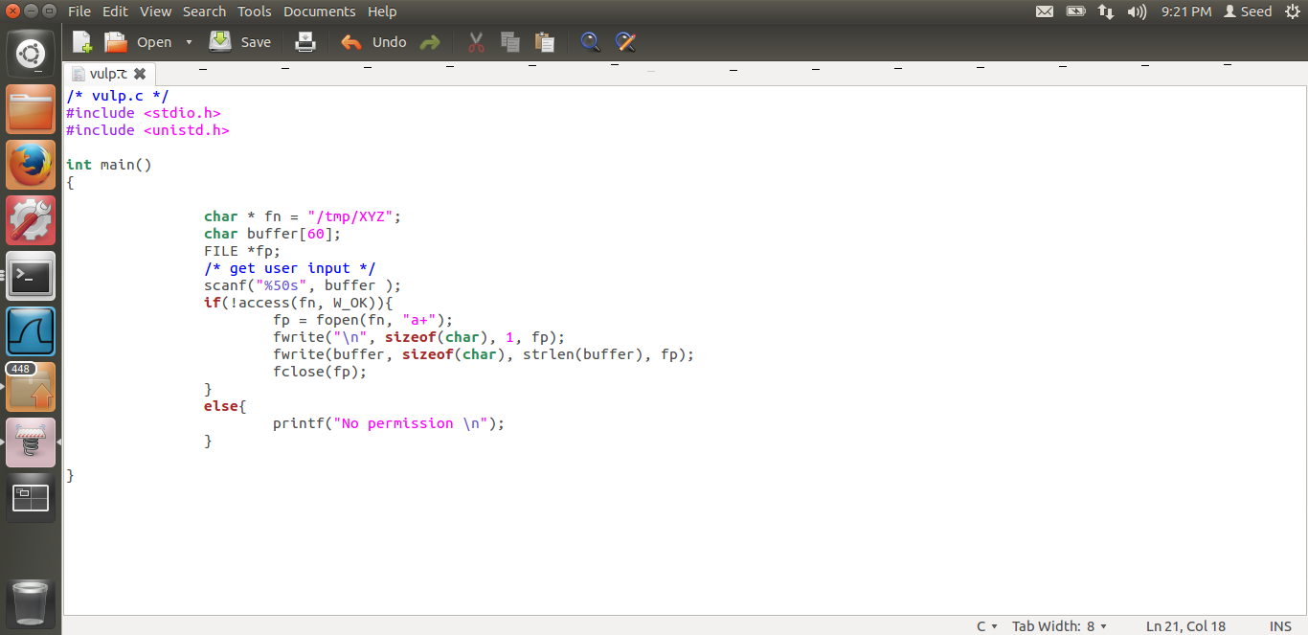

I have changed the vulnerable program to the original program.

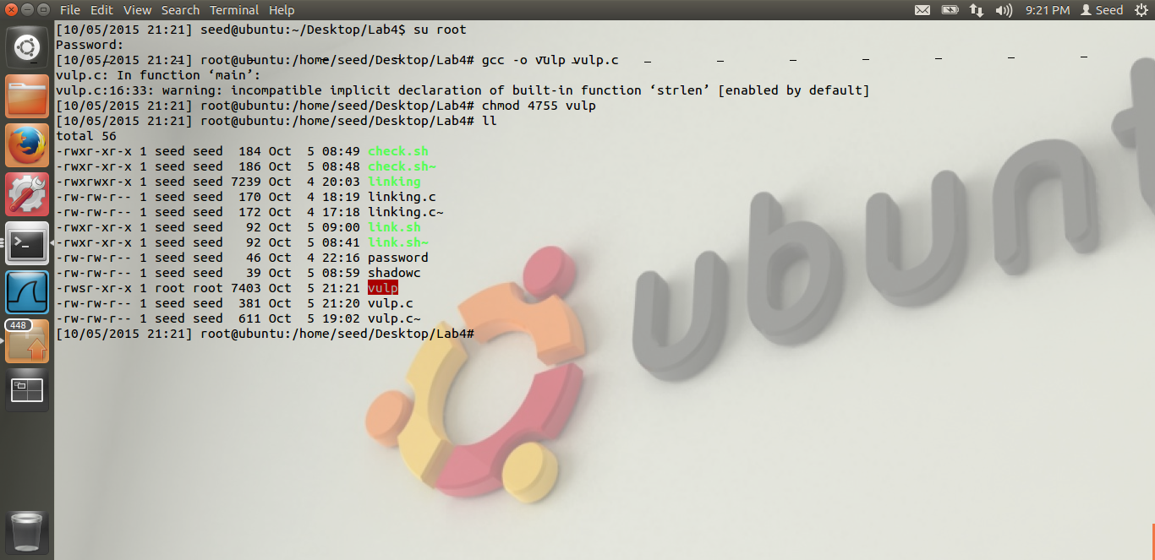

Made it a set-UID program.

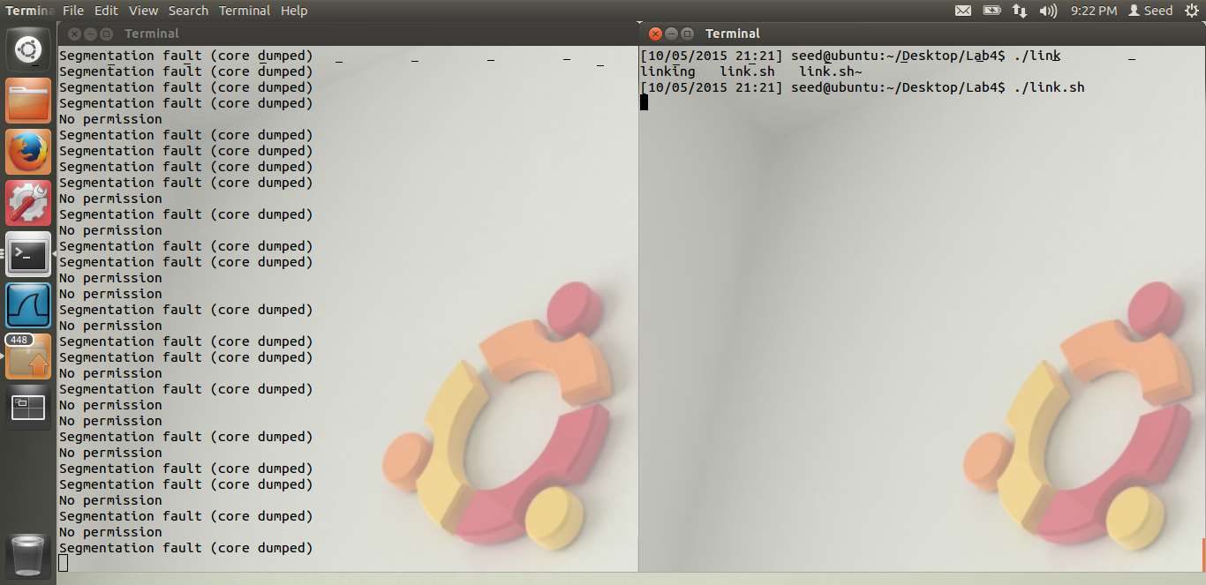

Now, when I run the program, I am getting segmentation fault core dump and no permission, i.e. I am not able to attack the system, do the race condition attack. Its giving segmentation fault, i.e. my code is accessing memory which is not accessible to me. This is due to ubuntu’s built in symlink protection scheme.

1. **Why does this protection scheme works?**

This works, because of the sticky bit in the world writable sticky directories, i.e. /tmp in our case. The follower and the directory owner, if it does not match the symlink owner, then the follower cannot follow the symlink, i.e. soft link. Thus, the “sticky bit” on the directory is set to prevent users from deleting other user’s files. Thus, this fixes the user’s ability to follow symlinks in sticky directories. Hence this attack works, as the file is owned by seed, user, i.e. the /tmp/XYZ file, the follower is the user, but the /etc/passwd directory is owned by the root, hence because of this mismatch, the user cannot follow the link.

1. **Is this a good protection scheme, Why or Why not?**

We may argue that this is a good protection scheme. It works in most of the cases, as the owner if the follower is a normal user, and the file he wants to write to is owned by the root, this scheme will definitely work. But there is a way around this too.

1. **What are the limitations of the scheme?**

The limitations could be, what if the follower, and the link owner both are root. I can change the link owner to be root using lchown to be the root. Thus as the follower I can make it to be root, then if the check happens, the follower, directory owner and link owner would match. Thus, also, I can write a file and make it owned by the root and then in that file, create a link, owned by the root, Thus all the check conditions satisfies. Also, as the sticky bit is for world readable directories only, the user can create his own directory, make root as the owner and then try the attack. Thus, I feel this will make the attack work as it will satisfy all the conditions.